First Name: Ioana/Ion Surname: Popescu
Gender: Female or Male
Photo:
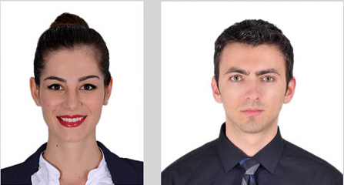
Address: str Avram Iancu, Nr 39, village: Popesti, City: Cluj-Napoca, County: Cluj-Napoca Country: Romania, Postal Code: 407500
Date of birth: 05.0X.19XX Place of birth: Cluj-Napoca/Romania
Citizenship: Romanian,etc
Phone number: 004/07XX.326.8XX
Facebook:
E-mail:
CPR(only for Denmark): 050X7X-4XXX
CNP(only for Romania): 1XXX05120XXX
APPLICANT INFORMATION:
Personal code: -
Age: 25 years Valid driving license: Yes/No What Categories:
English language (in terms of conversation): Poor/Moderate/Good/Excellent
Subject Shoe size: 42 Height: 175 Weight: 80
Marital status: Married/Unmarried Children: Yes/No Smoker: Yes/No/Occasionally
Hobby/sports: Fishing/Running, Bodybuilding, Football, etc
Do you want to work in: Denmark: YES/No, Ireland: Yes/ No, England: Yes/No, Romania: Yes/No
Other E.U. country: Yes/No
Future plans: To succeed in Denmark, Ireland, and England
Interested in which domains: Farming, etc.
Abilities:
Other subjects in Agriculture: Pigs, Cows, Hens, Greenhouses
Available start date: 15 July 2019
Desired salary: negotiable or enter your wage claims.
Desired region of the country: it is not important
Accommodation: required
Various: I am a social person, and I can also adapt to any type of work
EDUCATION:
1. Education level: High school Name of school: Liceul Anghel Saligny from: Cluj-Romania
Year of your last graduation: 20XX Age: 18 years Years of study: 12 classes
Specialization at graduation: Painter in construction
2. Education level: University level Name of school: GH. Asachi University from: Romania
Year of your last graduation: 20xx Age: 23 yo Years of study: 5 classes
Specialization at graduation: Construction
3. Education level: Master level Name of school: GH. Asachi University from: Romania
Year of your last graduation: 20xx Age: 23 yo Years of study: 5classes
Specialization at graduation: Construction
REFERENCES - work experience:
1. Employer: Self-employed Address: Iasi, Romania
From: 01.08. 2006 To: 01.02.2013 Position: worker and team manager in construction
Duties: in the beginning, I worked together with my construction team, being involved in
all phases of building a house and after I coordinated the construction team.
2. Employer: Green Fiber - Recycling waste factory Address: Iasi, Romania
From: 01.03. 2013 To: 01.06. 2016 Position: factory worker
Duties: checking temperatures, pressure, and changing filters

3. Employer: Konsdal Multisite A/S Phone no: 30.xx.xx.67- Gorm Toftegaard
Address: Danmark
Farm details: 1300 soer and 860 ha
From: July 2016 To: Feb. 2019 Position: farmer worker
Duties: working in lobestald and draegstald mainly, and helping other workers in other sectors like: farestable and klimastable.

4,5,6…etc … other work experiences if it is the case.

Other comments:
Signature:

